Experiment-5

Name: Hemant Singh UID: 22BCS12820

Subject: Advance Programming Section: 614_B

Q.1 <https://leetcode.com/problems/maximum-depth-of-binary-tree/submissions/1569120055/>

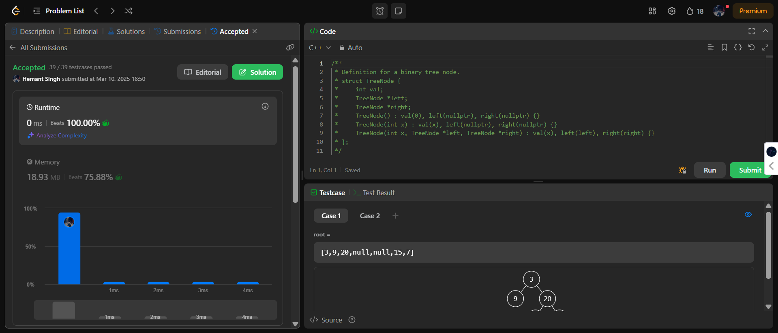

Q2. <https://leetcode.com/problems/validate-binary-search-tree/submissions/1569120862/>

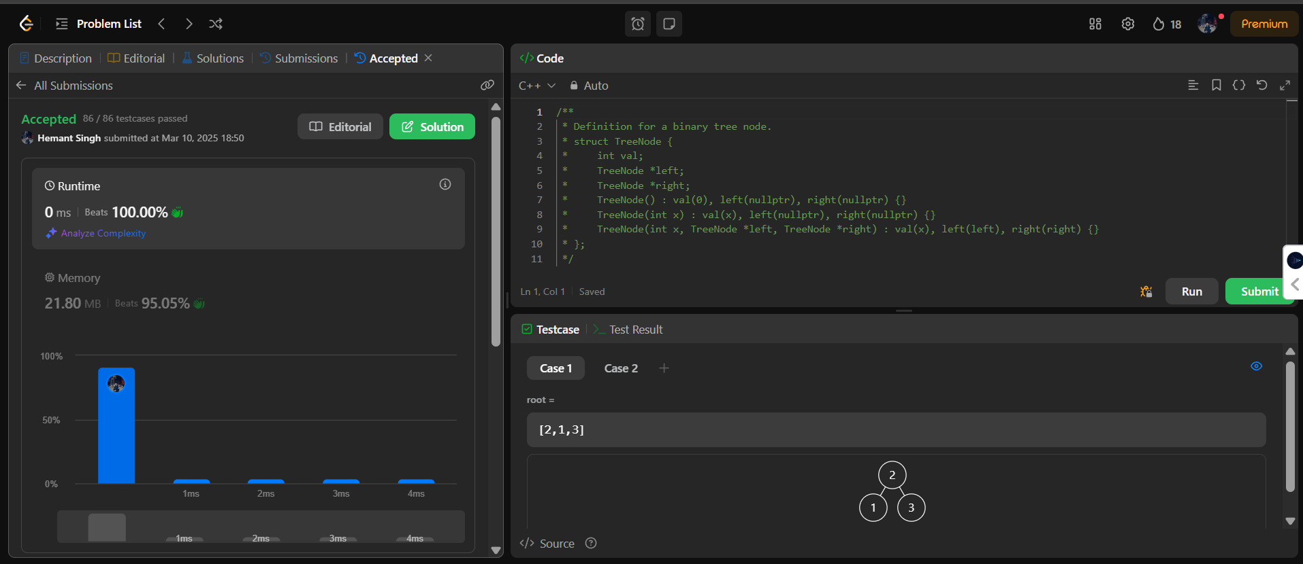

Q3. <https://leetcode.com/problems/symmetrictree/submissions/1569121529/>

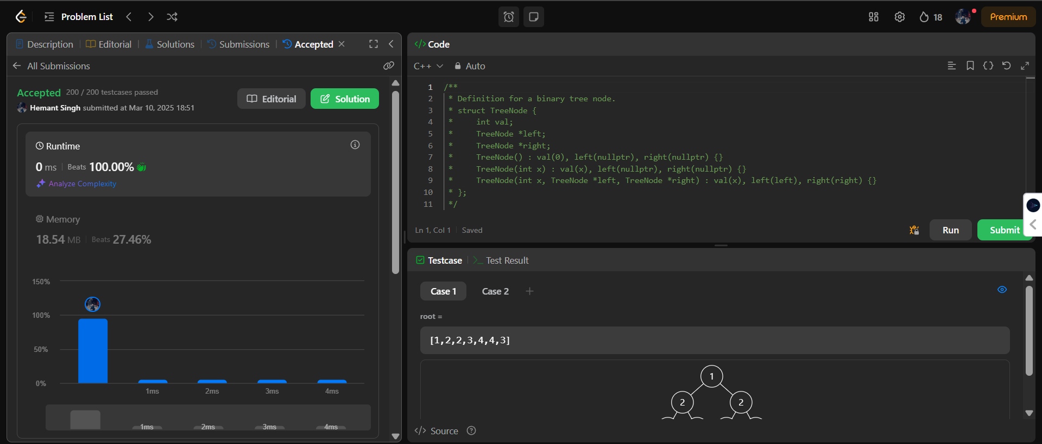

Q4. <https://leetcode.com/problems/binary-tree-zigzag-level-order-traversal/submissions/1569124634/>

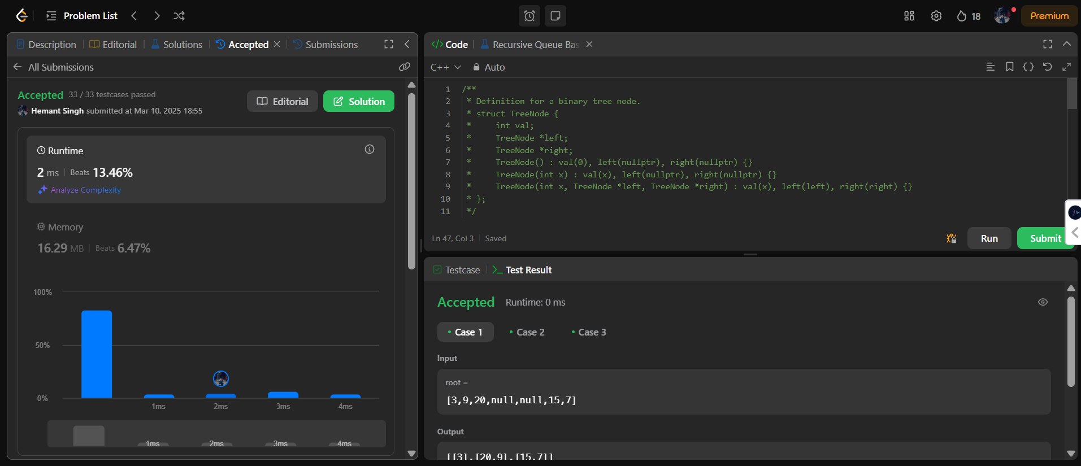

Q5. <https://leetcode.com/problems/lowest-common-ancestor-of-a-binary-tree/submissions/1569126102/>

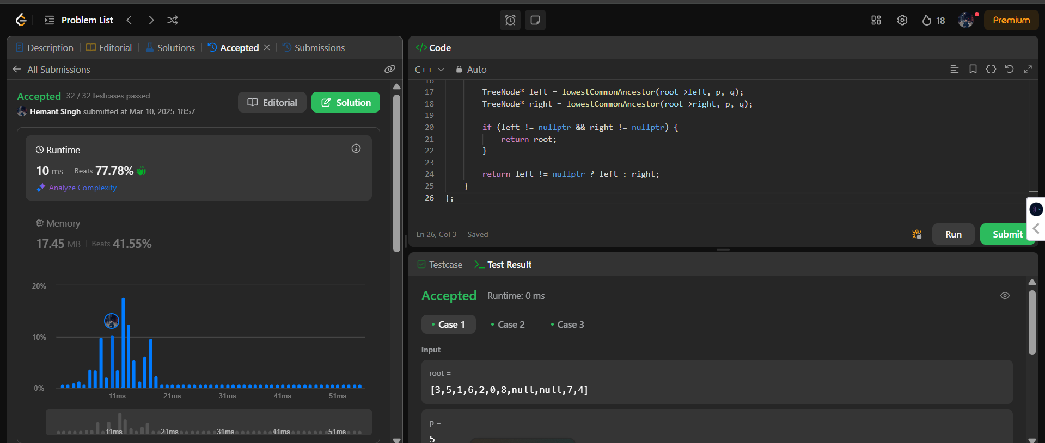

Q6. <https://leetcode.com/problems/binary-tree-inorder-traversal/submissions/1569126711/>

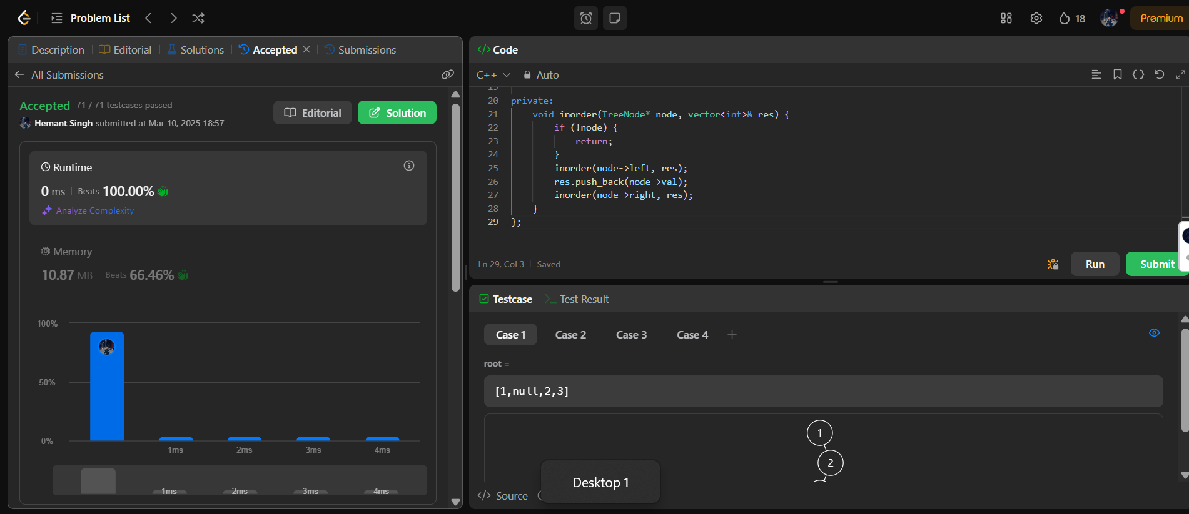

Q7. <https://leetcode.com/problems/binary-tree-level-order-traversal/submissions/1569127171/>

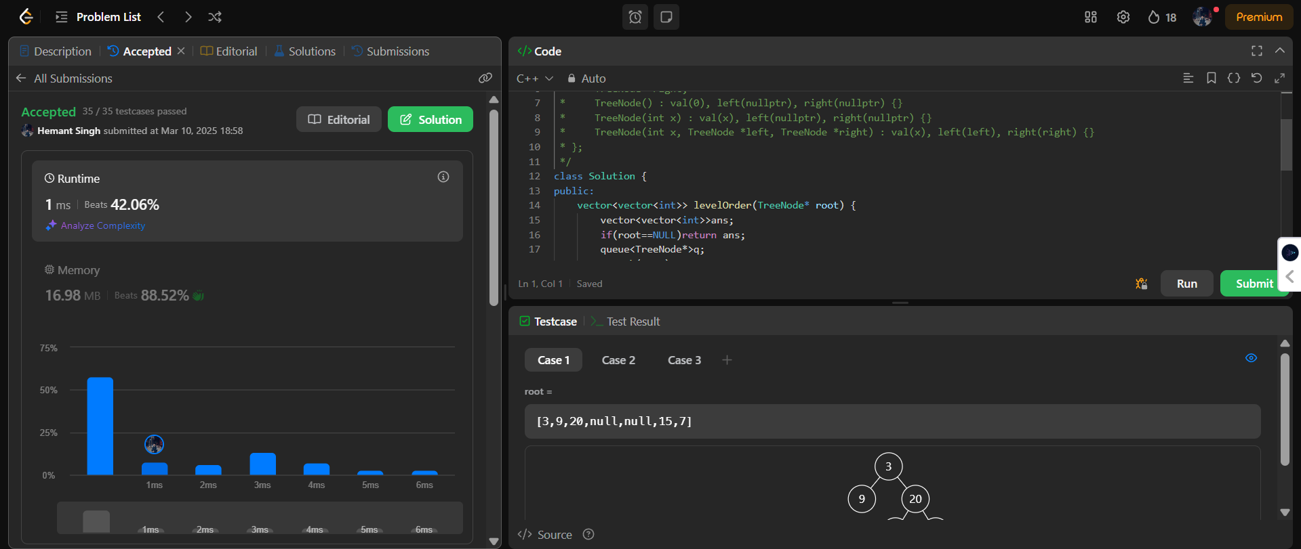

Q8. <https://leetcode.com/problems/kth-smallest-element-in-a-bst/submissions/1569127768/>

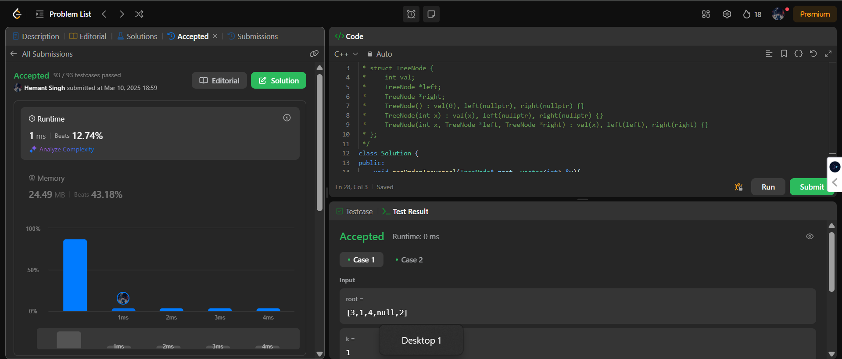

Q9. <https://leetcode.com/problems/populating-next-right-pointers-in-each-node/submissions/1569128326/>

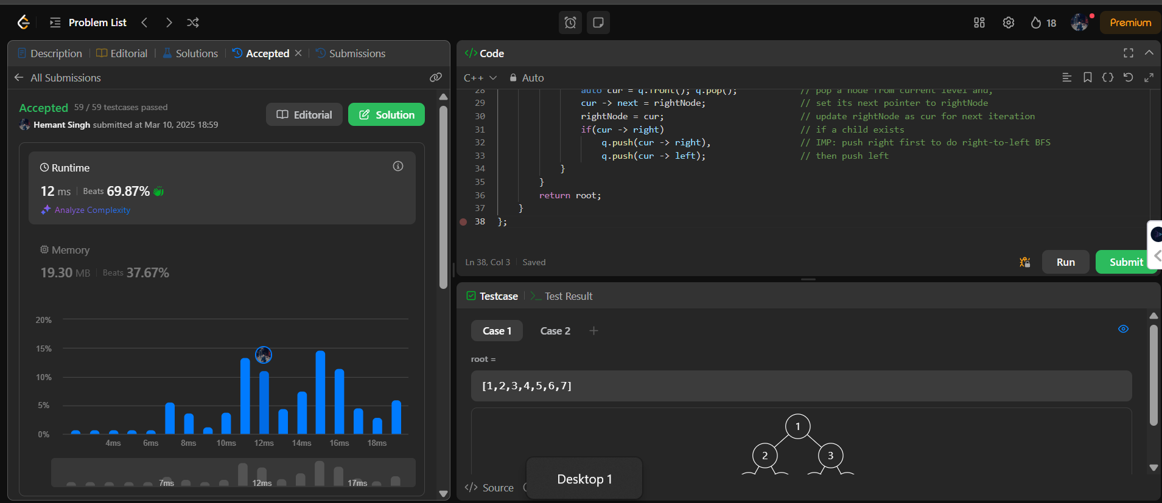

Q10. <https://leetcode.com/problems/sum-of-left-leaves/submissions/1569128845/>

